MATLAB programs from chapter 3

Program 1: A program to use Homomorphic processing and extract the impulse response of the vocal tract.
%Homomorphic processing for voiced speech to find impulse response of vocal
%tract
clear all;
fp=fopen('watermark.wav');
fseek(fp,224000,-1);
a=fread(fp,2048);
subplot(2,1,1);plot(a);title('plot of voiced part of a signal');
xlabel('sample no.');ylabel('amplitude');
b=fft(a);
b1=abs(b);
c=log(b1);
subplot(2,1,2);plot(c);title('plot of log spectrum of a signal');
xlabel('fft sample no.');ylabel('log magnitude in dB');
w=fir1(50,0.01,'low');
x=conv(c,w);
%a=[1 0.2 0.1 0.01];b=[1]
%d=filter(a,b,c);
figure;
subplot(2,1,1);plot(x);title('plot of filtered log spectrum');
xlabel('sample no.');ylabel('amplitude');
y=exp(x);
z=ifft(y);
z1=abs(z);
for i=1:1024,
z11(i)=z1(i);
end
subplot(2,1,2);stem(z11);title('plot of impulse response of vocal tract');
xlabel('sample no.');ylabel('amplitude');

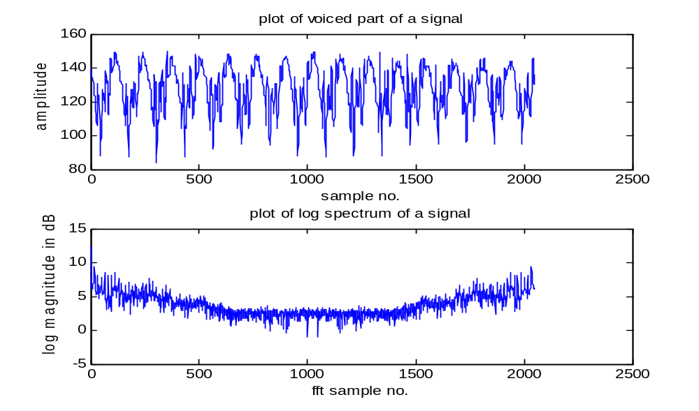
Figure 3.2 Plot of voiced speech segment and its log magnitude
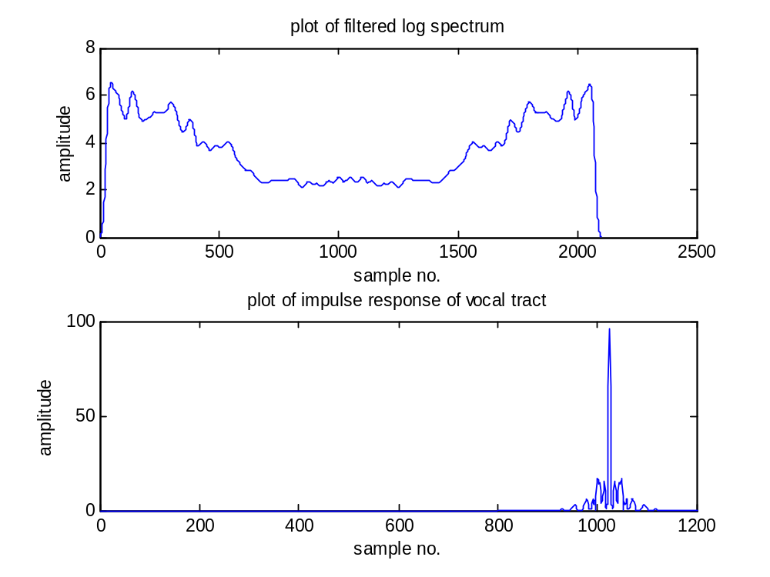
Figure 3.3 Plot of the filtered log spectrum and impulse response of vocal tract.

Program 2: t find the cepstral coefficients for voiced speech segment.

%to find cepsrtal coefficients the voiced signal
clear all;
fp=fopen('watermark.wav');
fseek(fp,224000,-1);
a=fread(fp,2048);
a=a-128;
subplot(2,1,1);plot(a);title('plot of voiced part of a signal');
xlabel('sample no.');ylabel('amplitude');
%2048 samples of the voiced signal are displayed

a1=window(@Hamming,2048);
for i=1:2048,
a11(i)=a(i)*a1(i);
end
subplot(2,1,2);
plot(a11);title('plot of windowed voiced part of a signal');
xlabel('sample no.');ylabel('amplitude');
%the signal is passed via Hamming window and displayed.
b=abs(fft(a11));
f = 22100/2048:22100/2048:22100;
c=log(b);
figure;
for i=1:1024,
d(i)=c(i);
end
f = 22100/2048:22100/2048:11050;
subplot(2,1,1);plot(f,d);
title('log spectrum of windowed voiced speech signal');
xlabel('Frequency in Hz');ylabel('amplitude in dB');
e=abs(ifft(c));
subplot(2,1,2);plot(e);
title('cepstrum of voiced speech signal');
xlabel('Quefrency');ylabel('amplitude in dB');

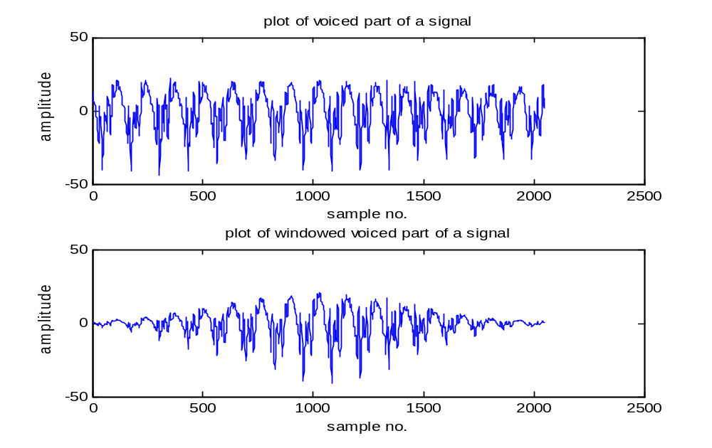
Figure 3.5 Plot of signal and windowed signal.
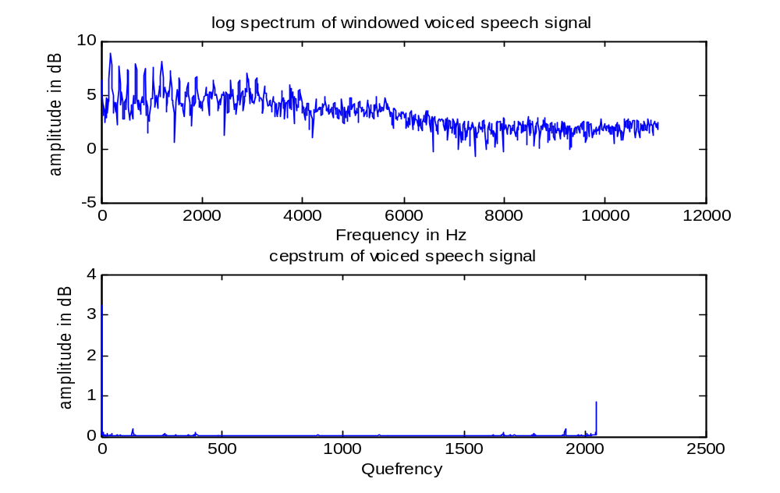
Figure 3.6 Plot of log spectrum and cepstrum

Program 3: A MATLAB program to convert frequency to mel scale is given below.
%program to convert frequency in Hz to Mel Scale
clear all;
for i=1:11050,
m(i)=2595*log(1+i/700);
end
plot(m);title('mapping of frequency in Hz to Mel scale');
xlabel('frequency in Hz');ylabel('Mel frequency');

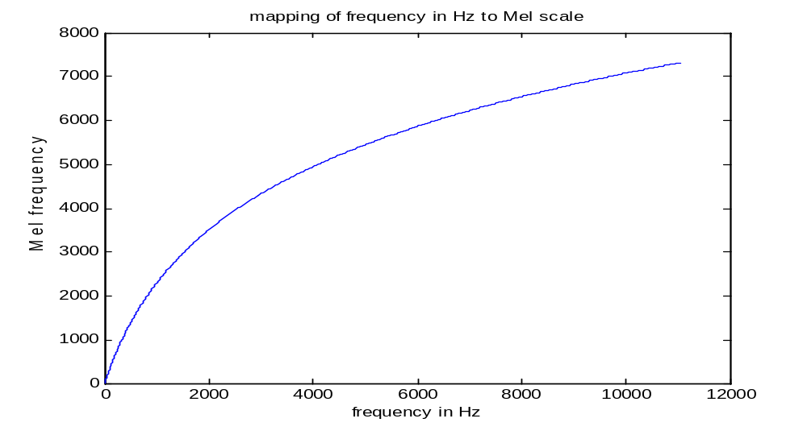
Figure 3.7 Frequency warping using mel scale.

Program 4: A MATLAB program to convert frequency in bark scale is given below.
Clear all;
for i=1:11050,
f(i)=frq2bark(i);
end
plot(f);title('plot of bark frequency Vs frequency');
xlabel('frequency in Hz');ylabel('frequency in bark scale');

A plot of frequency in bark scale to frequency in Hz is depicted in Figure 3.8.

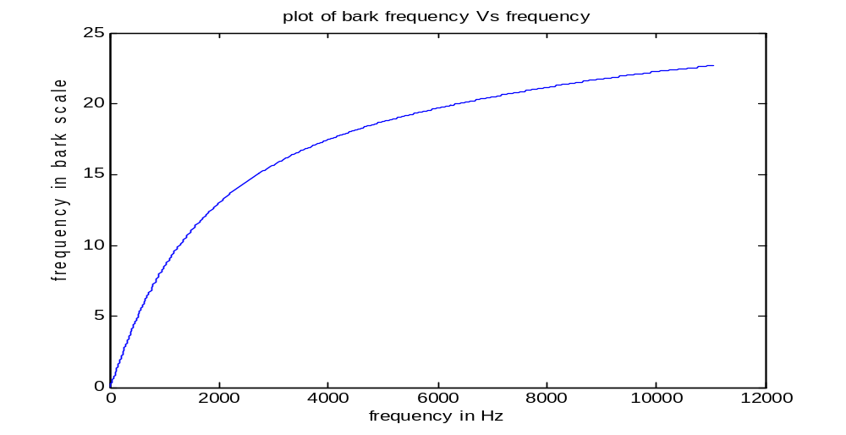
Figure 3.8 Plot of bark frequency and frequency in Hz.

Program 5: A MATLAB program to calculate MFCC for a speech segment of size 256 is given below. The reader is encouraged to track the steps by going through the comments in the program.

%program to convert frequency in Hz to Mel Scale
clear all;
fp=fopen('watermark.wav');
fseek(fp,224000,-1);
a=fread(fp,256);
%plot 256 points of voiced speech
subplot(2,1,1);plot(a);title('plot of voiced part of a signal');
xlabel('sample no.');ylabel('amplitude');
%find 256 point FFT
b=fft(a);
b1=(abs(b));
for i=1:256,
b1(i)=b1(i)*b1(i); %calculation of squared power spectrum
end

c=log10(b1);
%calculate frequency in Hz for every FFT bin
for i=1:128,
f(i)=22100/256*i;
end
for i=1:128,
c1(i)=c(i);
end
%calculate mel scale frequency for each frequency
%in HZ corresponding to FFT bin
for i=1:128,
m(i)=2595*log(1+f(i)/700);

end
%plot log spectrum in mel scale foe each FFT bin
subplot(2,1,2);stem(m,c1);title('plot of log spectrum in Mel scale for voiced speech');
xlabel('Frequency in Mel scale');ylabel('Amplitude in dB');

%divide mel scale in equally spaced triangular filter each of width equal to 300 mel with 50% overlap. first filter is from 300 mel to 600 mel. Next is from 450 mel to 750 mel and so on. integratpe log power spectrum bins over the filter width
for j=1:28,
sum(j)=0;
for i=1:58,

if ((m(i)>300+(j-1)*150)&&(m(i)<600+(j-1)*150))
if (m(i)<450+(j-1)*150)
g(i)=((m(i)-(300+150*(j-1)))*1/150);
else
g(i)=((600+150*(j-1)-m(i))*1/150);
end

sum(j)=sum(j)+c1(i)*g(i);

end

end
end
%find ifft of the integrated output. This is a cepstral domain.
d=ifft(sum);
d=abs(d);

figure;

for i=1:14,
x(i)=d(i);
end
%plot first 14 MFCC coefficients by cepstral truncation.
stem(x);title('plot of MFCC for voiced speech');
xlabel('Frequency in Mel scale');ylabel('Amplitude in dB');

Figure 3.8 shows a plot of the signal and its log power spectrum for each fft bin on mel scale. Figure 3.9 shows a plot of corresponding MFCC points.

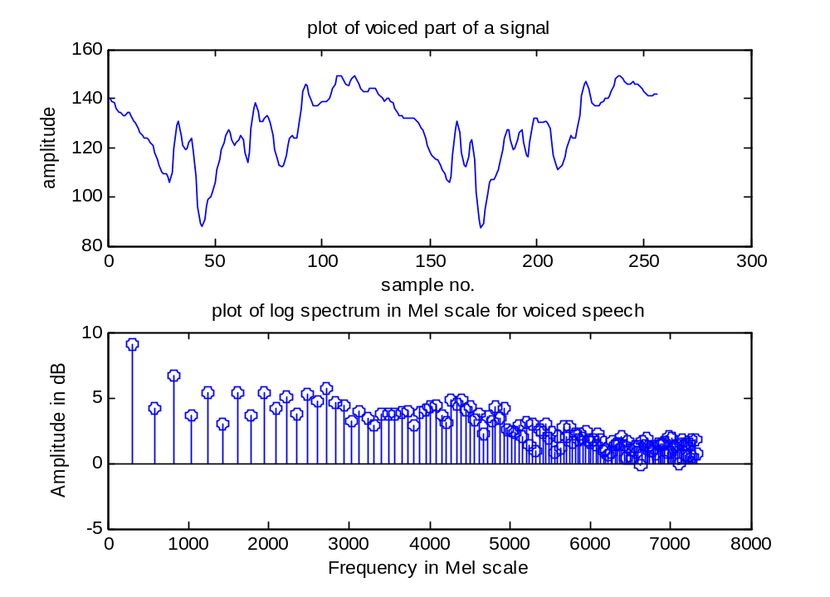
Figure 3.8 Plot of speech and its log power spectrum for each fft point on mel scale.
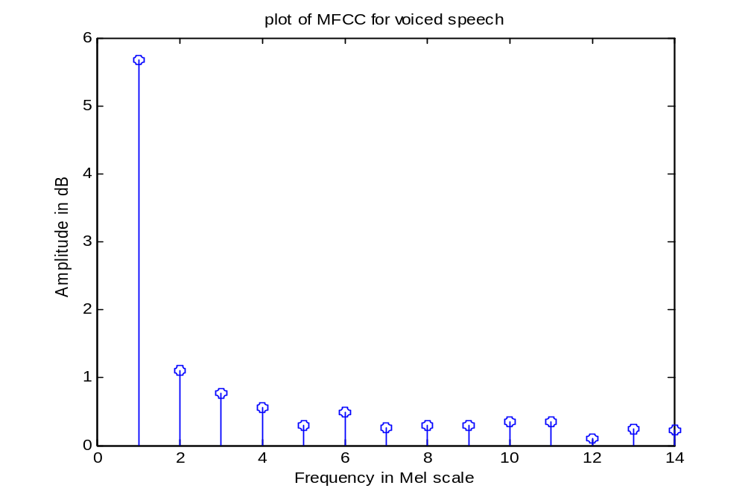
Figure 3.9 Plot of 14 MFCC points.

Program 6: We can calculate MFCC using melcepst command in voice box. . Melcepst command uses DCT in place of IFFT to convert spectrum coefficients to cepstral coefficients.

%program to calculate MFCC for voiced speech signal using MFCC command
clear all;
fp=fopen('watermark.wav');
fseek(fp,224000,-1);
a=fread(fp,256);
subplot(2,1,1);plot(a);title('plot of voiced part of a signal');
xlabel('sample no.');ylabel('amplitude');
b=fft(a);
b1=abs(b);
c=log(b1);
for i=1:256,
f(i)=22100/256*i;
end
for i=1:256,
c1(i)=c(i);
end

for i=1:256,
m(i)=2595*log(1+f(i)/700);
end
subplot(2,1,2);plot(m,c1);title('plot of log spectrum in Mel scale for voiced speech');
xlabel('Frequency in Mel scale');ylabel('Amplitude in dB');

x=melcepst(a);

figure;
plot(x);title('plot of MFCC using MATLAB command for voiced speech');
xlabel('Frequency in Mel scale');ylabel('Amplitude in dB');

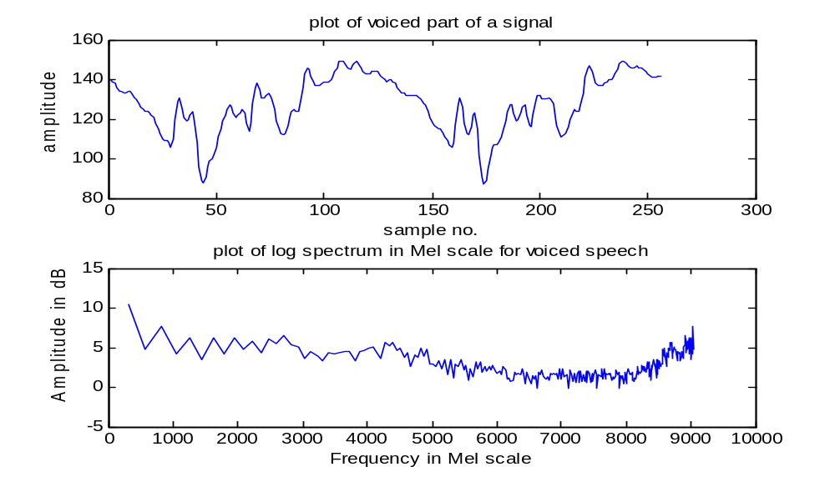
Figure 3.10 Plot of voiced speech and its log spectrum in mel scale.
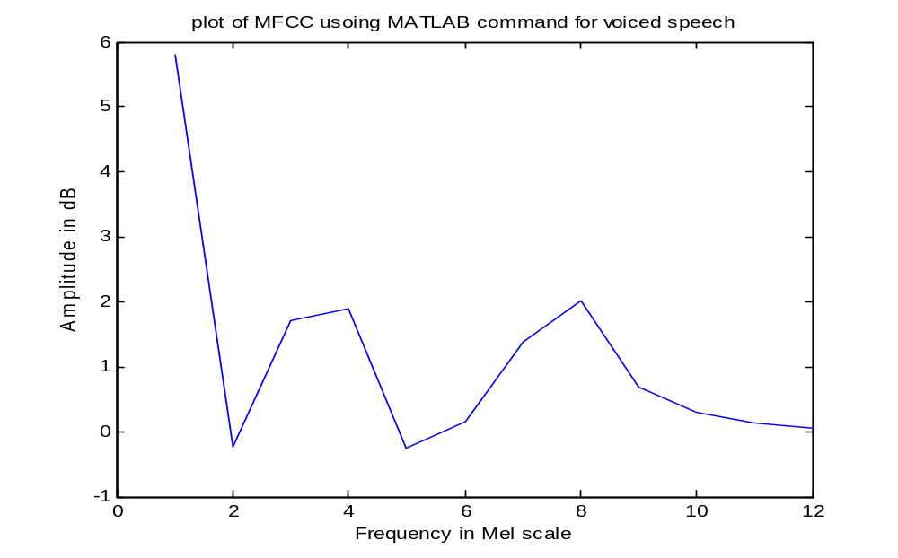
Figure 3.11 Plot of 12 MFCC using MATLAB command melcepst

Program 7: A MATLAB program for calculation of PLP is given below.
%program to find PLP coeffcients for 256 samples of voiced speech
clear all;
fp=fopen('watermark.wav');
fseek(fp,224000,-1);
a=fread(fp,256);
%plot 256 points of voiced speech
subplot(2,1,1);plot(a);title('plot of voiced part of a signal');
xlabel('sample no.');ylabel('amplitude');
%find 256 point FFT
b=fft(a);
b1=(abs(b));
for i=1:256,
b1(i)=b1(i)*b1(i); %calculation of squared power
end

%calculate frequency in Hz for every FFT bin
for i=1:128,
f(i)=22100/256*i;
end
for i=1:128,
c1(i)=b1(i);
end
%calculate bark scale frequency for each frequency in HZ corresponding to FFT bin
for i=1:128,
bark(i)=6*log(2*pi*f(i)/1200*pi+sqrt((2*pi*f(i)/1200*pi)^2+1));

end
%plot spectrum in bark scale foe each FFT bin. And find cube root of power spectrum bin and plot it on bark scale.

for i=1:128,
c11(i)=nthroot(c1(i),3);
end

subplot(2,1,2);stem(bark,c11);title('plot of cube root of power spectrum in bark scale for voiced speech');
xlabel('Frequency in bark scale');ylabel('Amplitude in dB');
%divide bark scale in equally spaced triangular filter each of width equal to 5 bark with 50% overlap. first filter is from 10 bark to 15 bark. Next is from 12.5 bark to 17.5 bark and so on. integrate cube root of power spectrum bins over the filter
figure;
for j=1:28,
sum(j)=0;
for i=1:58,

if ((bark(i)>10+(j-1)*2.5)&&(bark(i)<15+(j-1)*2.5))
if (bark(i)<12.5+(j-1)*2.5)
g(i)=((bark(i)-(2.5+2.5*(j-1)))*1/5);
else
g(i)=((15+2.5*(j-1)-bark(i))*1/5);
end

sum(j)=sum(j)+c11(i)*g(i);

end

end
end
%find ifft of the resulting integrated values considering it as a signal.
d=ifft(sum);
d1=real(d);

for i=1:14,
x(i)=d1(i);
end
%plot first 14 MFCC coefficients by cepstral truncation.
stem(x);title('plot of PLP coefficients for voiced speech');
xlabel('Frequency in Mel scale');ylabel('Amplitude in dB');
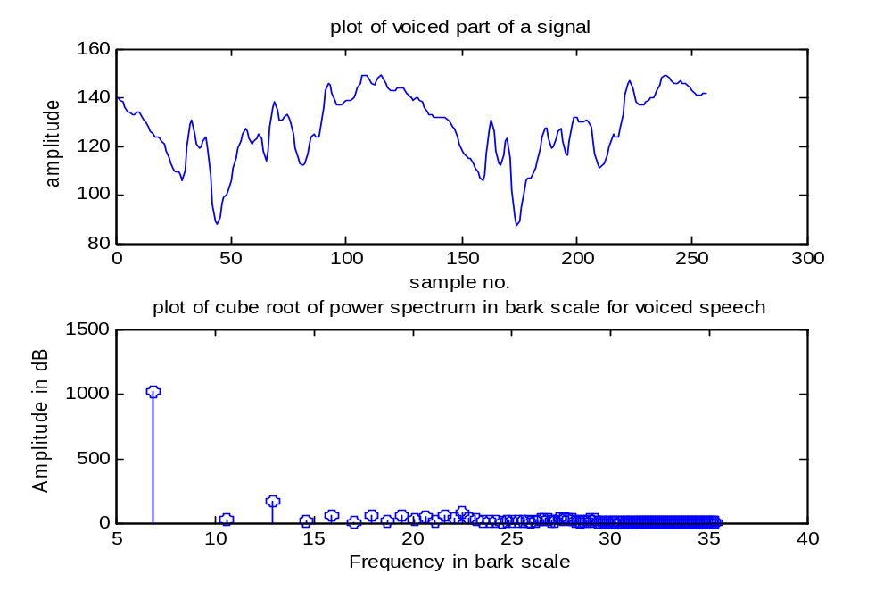
Figure 3.14 Plot of signal and its cube root of power spectrum

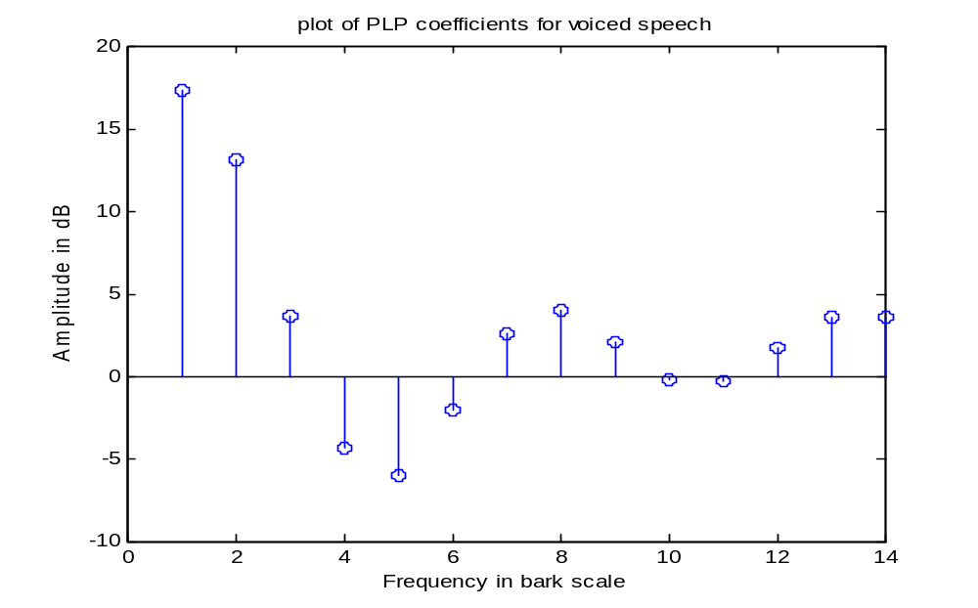
Figure 3.15 Plot of PLP values

Program 8: A MATLAB program to find LFPC is given below.
%program to find LFPC coeffcients for 256 samples of voiced speech
clear all;
fp=fopen('watermark.wav');
fseek(fp,224000,-1);
a=fread(fp,256);
%plot 256 points of voiced speech
subplot(2,1,1);plot(a);title('plot of voiced part of a signal');
xlabel('sample no.');ylabel('amplitude');
%find 256 point FFT
b=fft(a);
b1=(abs(b));
for i=1:256,
b1(i)=b1(i)*b1(i); %calculation of squared power
end

%calculate frequency in Hz for every FFT bin
for i=1:128,
f(i)=22100/256*i;
end
for i=1:128,
c1(i)=b1(i);
end
%calculate bark scale frequency for each frequency
%in HZ corresponding to FFT bin
for i=1:128,
bark(i)=6*log(2*pi*f(i)/1200*pi+sqrt((2*pi*f(i)/1200*pi)^2+1));

end
%plot log spectrum in bark scale foe each FFT bin

subplot(2,1,2);stem(bark,c1);title('plot of power spectrum in bark scale for voiced speech');
xlabel('Frequency in bark scale');ylabel('Amplitude in dB');
%divide mel scale in equally spaced triangular filter each of width equal
%to 300 mel with 60% overlap. first filter is from 300 mel to 600 mel. next
%is from 450 mel to 750 mel and so on. integrate log power spectrum
%bins over the filter
figure;
for j=1:40,
sum(j)=0;
for i=1:58,

if ((bark(i)>10+(j-1)*2.5)&&(bark(i)<15+(j-1)*2.5))
if (bark(i)<12.5+(j-1)*2.5)
g(i)=((bark(i)-(10+2.5*(j-1)))*1/5);
else
g(i)=((15+2.5*(j-1)-bark(i))*1/5);
end

sum(j)=sum(j)+c1(i)*g(i);

end

end
end

for i=1:14,
x(i)=sum(i);
end
%plot first 14 LFPC coefficients by cepstral truncation.
stem(x);title('plot of LFPC coefficients for voiced speech');
xlabel('Frequency in bark scale');ylabel('Amplitude in dB');

Figure 3.17 shows signal and its power in bark scale and Figure 3.18 gives a plot of LFPC. We find that the graph of LFPC shows increasing nature. This is because when we integrate over equally spaced windows, the number of fft bins falling in the higher frequency windows is increasing giving higher value of integration output. This justifies the increasing nature of LFPC graph. For low frequency filters, one fft bin falls in each window and depending upon the weight of the window for a bin, the LFPC may increase or decrease.
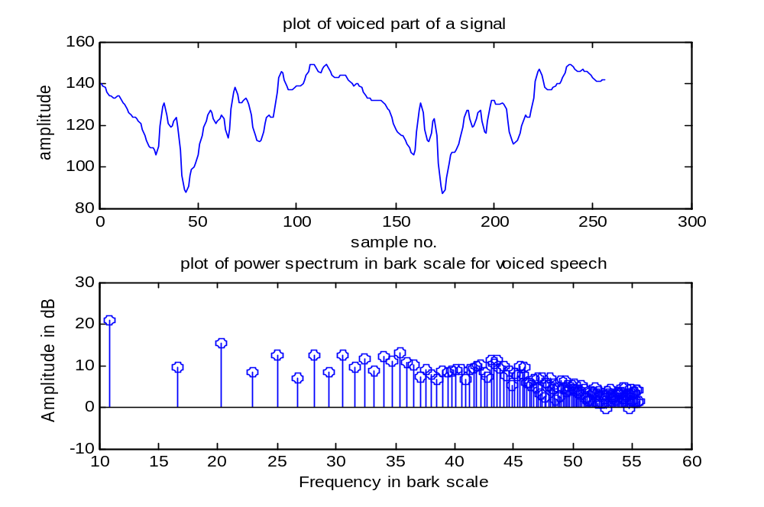
Figure 3.17 Plot of signal and its power spectrum in bark scale.

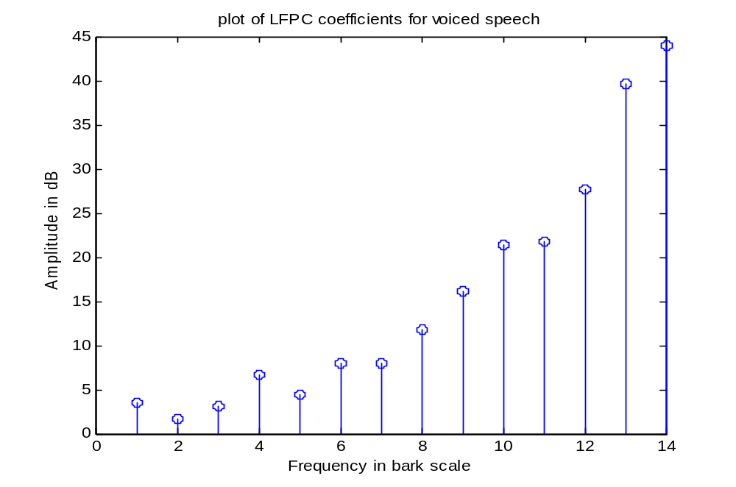
Figure 3.18 Plot of LFPC
Program 8: A MATLAB program to plot a 3D spectrogram is given as follows.

%plot of 3-D spectrogram
clear all;
fp=fopen('watermark.wav','r');
t=0:0.016:2; % 2 secs @ 16 kHz sample rate 256 samples at a time = 0.016 seconds data taken at a time.
fseek(fp,44,-1);
x=fread(fp,10024);
[y,f,t] = spectrogram(x,window,256);
%length of window is 256 samples with y as spectrogram
%amplitude varying with time and frequency
surf(t,f,10*log10(abs(y)));
xlabel('Time');ylabel('Frequency (KHz)');
zlabel('amplitude');

The time frequency tiling of STFT is shown in Figure 3.22. We can see that once the time domain window is fixed, frequency domain window also gets fixed and the size of the tile is constant throughout the analysis.
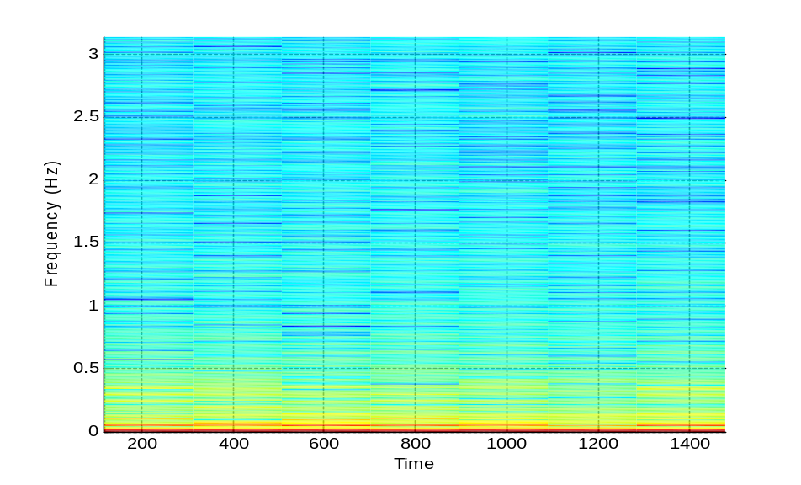
Figure 3.20 A 2D spectrogram of speech signal.
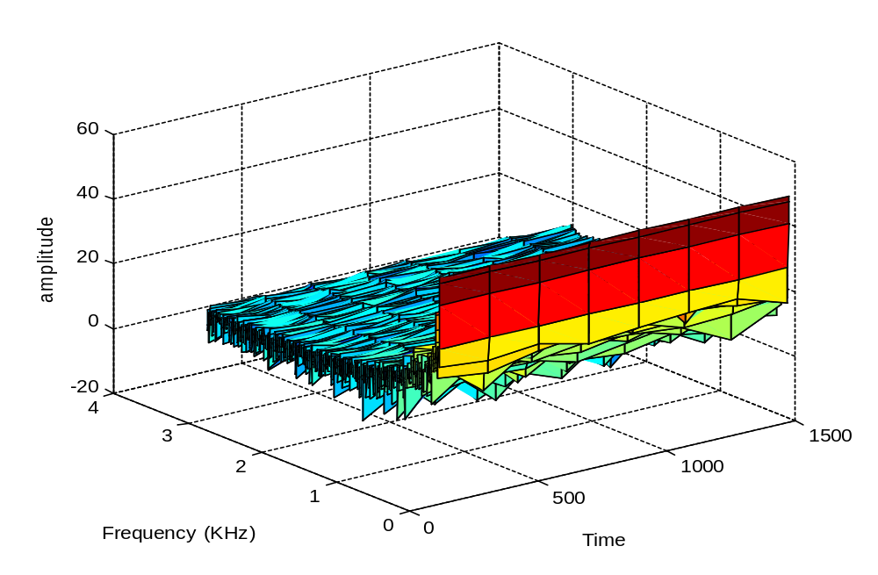

Figure 3,21 3-D spectrogram of speech signal.
Program 9:Program to find 2nd level wavelet decomposition for voiced speech signal using Haar wavelet
%program to find wavelet coefficients for 256 samples of voiced speech
%using Haar wavelet
clear all;
fp=fopen('watermark.wav');
fseek(fp,224000,-1);
a=fread(fp,256);
%plot 256 points of voiced speech
plot(a);title('plot of voiced part of a signal');
xlabel('sample no.');ylabel('amplitude');
[b,c]=dwt(a,'db1');
figure;
subplot(2,1,1);plot(b);title('plot of low resolution component of first level decomposition of voiced part of a signal');
xlabel('sample no.');ylabel('amplitude');

subplot(2,1,2);plot(c);title('plot of detail function of first level decomposition of voiced part of a signal');
xlabel('sample no.');ylabel('amplitude');
[b1,c1]=dwt(b,'db1');
figure;
subplot(2,1,1);plot(b1);title('plot of low resolution component of second level decomposition of voiced part of a signal');
xlabel('sample no.');ylabel('amplitude');

subplot(2,1,2);plot(c1);title('plot of detail function of second level decomposition of voiced part of a signal'); xlabel('sample no.');ylabel('amplitude');

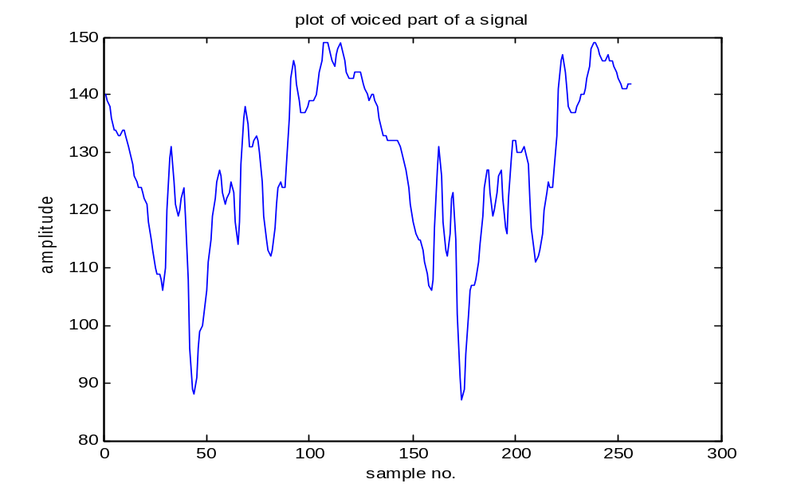
Figure 3.24 plot of speech signal (256 samples)

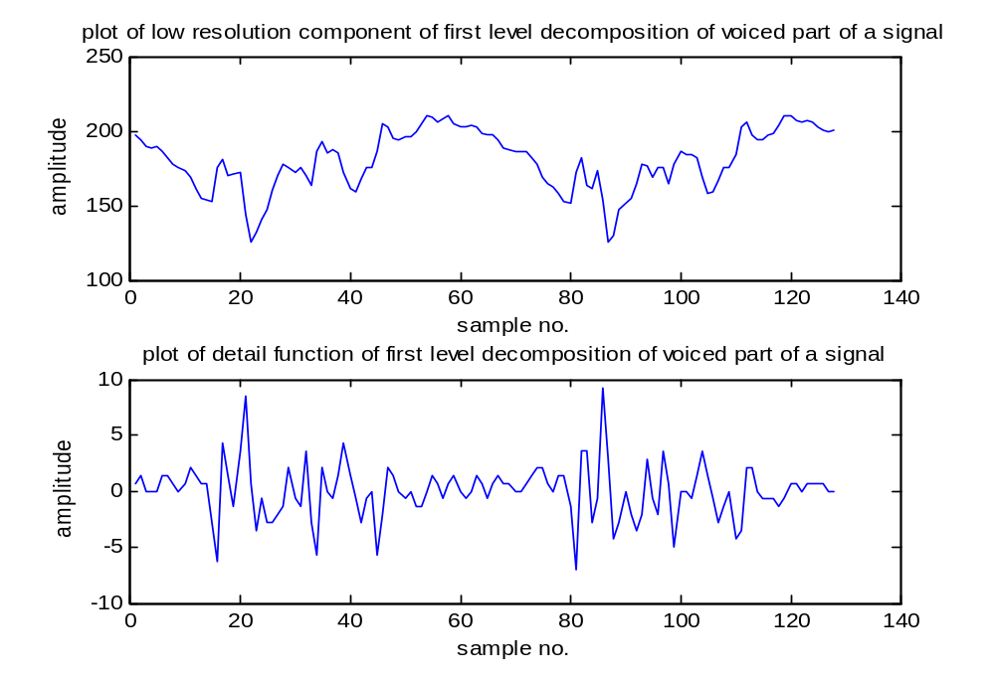
Figure 3.25 first level wavelet decomposition using Haar wavelet
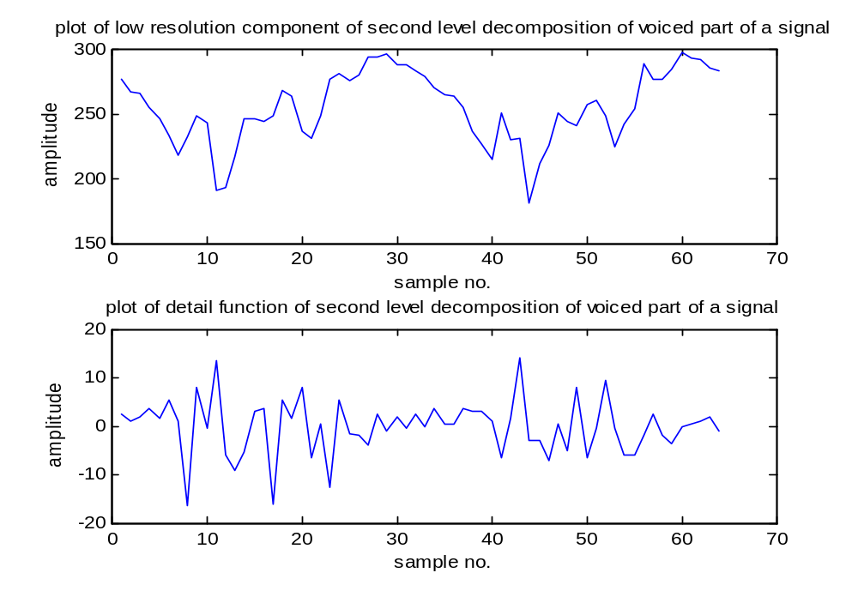
Figure 3.26 second level decomposition using Haar wavelet

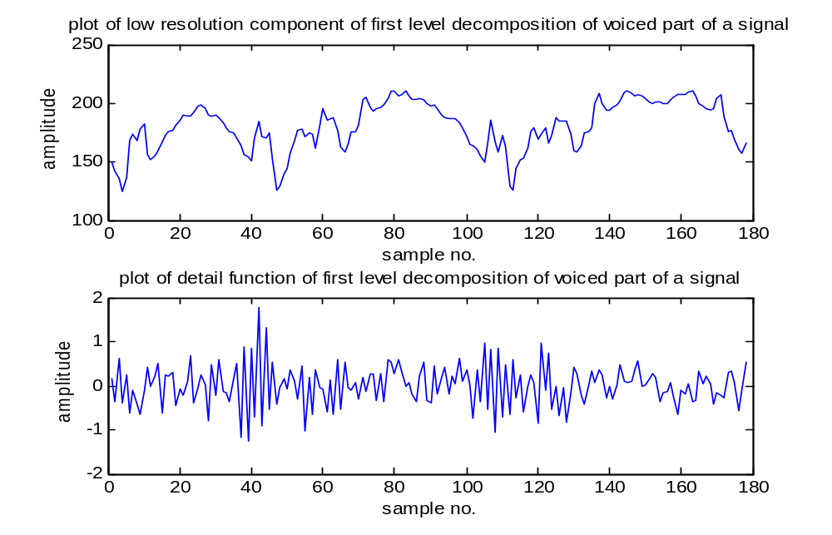
Figure 3.27 first level decomposition using Meyar wavelet

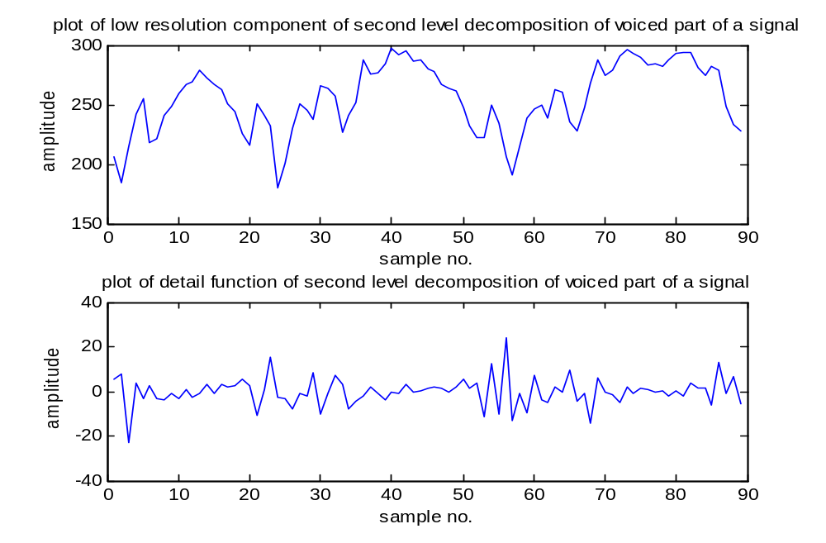
Figure 3.28 second level decomposition using Meyar wavelet

Figures 3.24, 3.25 and 3.26 show signal, its first level decomposition and second level decomposition respectively for 256 samples of speech. We have taken 256 speech signal samples. When we decompose using a Haar wavelet specified as ‘db1’ in the program using a DWT command in MATLAB, we get 128 low resolution components and 128 detail function components. For second level decomposition the low resolution function of first level decomposition is used as a signal and is decomposed further and we get 64 low resolution components and 64 detail function components as shown in Figure 3.25 and Figure 3.26 respectively. Figure 3.27 and Figure 3.28 show first and second level decomposition using Discrete Meyar wavelet. We have to specify a wavelet name as ‘dmey’ in place of ‘db1’ for Haar. The detail function of first level decomposition using Meyar wavelet has less amplitude than that for Haar decomposition.

